Code-Based Understanding Document
This document is created to help understand the Clean Architecture design implemented in the ShipsKart backend system and reasons behind using it.
Before exploring the implementation, let us first understand what Clean Architecture is.
Clean Architecture Design
Clean Architecture is a software design approach that helps you build applications in a way where the business logic is separated from external tools like databases, frameworks, UI, APIs, and third-party services.
In simple words we can say, business logic should not depend on the database, framework, UI, or external services. Instead, those external things should depend on your business logic. Due to this it’s very easy to maintain, test, scale and change in the future.
Why was Clean Architecture was designed?
It was designed to solve the problem of tightly coupled software. In many applications, business logic is directly mixed with database code, API code, UI code, or framework-specific code. Because of this, the application becomes difficult to change, test, and maintain.

For example, if the database changes from MongoDB to PostgreSQL, or if the framework changes, a poorly designed application may require changes in many places. This increases bugs and makes development slower.

Clean Architecture was created to avoid this problem by separating the business logic from external technologies.
The problems that it aimed to solve:
- Hard to maintain - small changes in one part of the system can affect many other parts.
- Hard to test - Business logic depends on databases, APIs, or frameworks, so testing becomes complicated.
- Hard to change technology - Replacing a database, framework, or external service becomes risky and time-consuming.
- Poor separation of responsibility - Code becomes messy because each file or class starts doing multiple things.
- Difficult to scale - As the application grows, adding new features becomes slower and more error-prone.

Clean Architecture Solved This
Clean Architecture solves these problems by dividing the application into layers such as:
- Domain Layer: Contains core business rules and entities.
- Application Layer: Contains use cases and application-specific logic.
- Infrastructure Layer: Handles databases, external APIs, file systems, email services, etc.
- Presentation Layer: Handles controllers, routes, UI, or API endpoints.
For Example, an onion has multiple layers. The most important part is inside, and outer layers cover it. In the same way, Clean Architecture keeps the most important business logic at the center, and technical details like database, UI, API, and frameworks stay outside
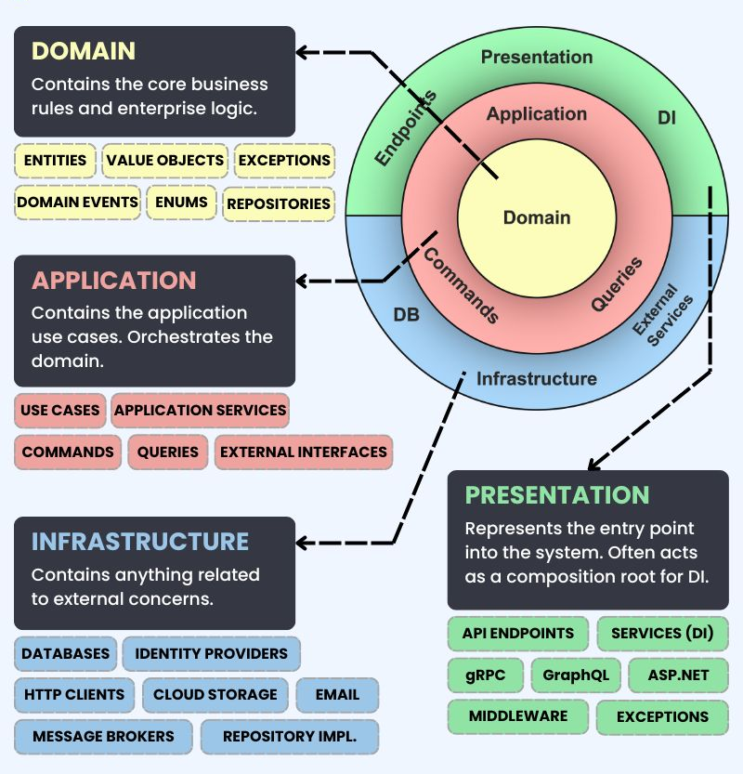
Now Let’s understand each layer one by one
- Domain Layer
This layer is the heart of the application; it contains the pure business logic of the system. It should not care about the database, framework or APIs or service. Its main aim is to answer the questions.
For Example, if we are building an order management system, then domain layer may contain: order, product, customer, payment or invoice as these represents the real business concepts.
let’s take another example, an order cannot be created without products or a cancelled order can’t be shipped. These are business rules, so they belong in the domain layer.
The Domain Layer should be independent and should not depend on any other layer.
Key Points:
- It is the core the application
- It contains business entities and rules
- It doesn’t depend on any external technology
- It should be pure and independent.
- It protects the most important logic of the system

- Application Layer
This layer contains the actions of the system and are called as use cases. It controls the flow of the business process. It doesn’t define the business rules itself, but it used the domain layer to apply those rules.
For example, in an Order Management System, the Application Layer may contain use cases such as:
- Create order
- Cancel order
- Ship order
- Generate invoice
- Process payment
- Update product stock
Each use case represents one action that the system can perform.
Let’s use a use case that is creating an order, application layer may follow this flow:
- Receive order details
- Check if customer exists
- Check if products are available
- Create order using domain rules
- Save order
- Return response
The Application Layer does not directly save data into the database. Instead, it depends on interfaces such as repositories. Like of creating order it may say “Save this order”. But it does not care whether the order is saved in PostgreSQL, MongoDB, or any other database.
The Application Layer acts like a coordinator. It connects the outer layers with the Domain Layer.
Key Points:
- It contains use cases.
- It controls the flow of the application
- It uses the Domain Layer.
- It does not directly depend on database implementation.
- It coordinates business operations.

- Infrastructure Layer
The Infrastructure Layer contains the technical details of the application. This layer is responsible for communicating with external systems such as databases, file systems, email services, payment gateways, cloud services, and third-party APIs.
For example, in an Order Management System, the Infrastructure Layer may contain:
- Database repository implementation
- Entity Framework configuration
- PostgreSQL connection
- Email service
- Payment gateway integration
- File storage service
- Logging service
- External API clients
Application layer may define interface, interface says what operations are needed then infrastructure layer provides the actual implementation of mentioned interface.
For Example, PostgreSQLOrderRepository (this class contains the real database code)
The benefit of this approach is that the Application Layer does not need to know which database is being used. If tomorrow we change from PostgreSQL to MongoDB, we only need to change the Infrastructure Layer. The Domain and Application Layers can remain mostly unchanged.
The Application Layer only knows about the interface.
The Infrastructure Layer knows the actual database code.
Key Points:
- It contains external and technical details.
- It handles database, email, files, APIs, and third-party services.
- It implements interfaces defined by inner layers.
- It can be changed without affecting business logic.
- It keeps technology separate from core logic.

- Presentation Layer
The Presentation Layer is the outermost layer of the application. This layer is responsible for receiving input from the user and returning output to the user.

In backend applications, the Presentation Layer usually contains:
- Controllers
- API endpoints
- Routes
- Request DTOs
- Response DTOs
- HTTP request handling

In frontend applications, it may contain:
- Pages
- Components
- Forms
- UI screens

For example, in an Order Management System, the Presentation Layer may contain API endpoints such as:
- POST /orders
- GET /orders/{id}
- PUT /orders/{id}/cancel
- PUT /orders/{id}/ship
When the user sends a request to create an order, the controller receives that request. The controller should not contain business logic. Its job is only to accept the request, validate basic input, and call the correct use case from the Application Layer.
The controller should not directly talk to the database. It should not contain rules like “cancelled order cannot be shipped”. That rule belongs in the Domain Layer.

The Presentation Layer is only a communication layer between the outside world and the application.

Key Points:
- It is the outermost layer.
- It handles user requests and responses.
- It contains controllers, routes, APIs, and DTOs.
- It calls the Application Layer.
- It should not contain business logic.

Request Flow Example
User sends request to create order
↓
Presentation Layer receives the request
↓
Application Layer runs CreateOrder use case
↓
Domain Layer checks business rules
↓
Infrastructure Layer saves order in database
↓
Response is returned to the user
Dependency Rule
Dependencies should always point inward. This means outer layers can depend on inner layer, but inner layer should not depend on outer layers.
Flow:
- Presentation -> Application -> Domain
- Infrastructure -> Application/Domain
It should not know about the controllers, databases, frameworks or APIs.

Why Clean Architecture Is Still Preferred?
- It Protects business logic: Business logic is the most valuable part of the application so it should be independent of the tech-stack used. Framework, Database, APIs, Cloud Provider changes but business logic doesn’t change frequently. It keeps the business rules independent from technical details.
- It makes code easier to maintain: In badly structure application, controller code, database code, validation code, and business logic are often mixed together. This creates code mash. This separation makes easy for developers to understand where a piece of code belongs.
- It makes testing easier: the business logic does not depend directly on the database or framework.
For example, a use case can be tested without running the real database.
Instead of using a real PostgreSQL database, we can use a fake repository during testing. This makes the testing and development faster and more reliable.
- It reduces dependency on frameworks: Modern frameworks are powerful, but application should not be completely dependent on them, these are just tools and should not control the business logic of the application. It helps keeping framework-specific code outside the core business logic.
- It makes technology replacement easier: it allows technology changes with less risk and if designed properly, most changes happen in infrastructure or presentation layer.
- Improves scalability of the codebase: Scalability is not only about handling more users; it’s also about handling more code and features. Clean architecture helps the codebase scale. As project grows, we can add new use cases, entities, repo and services in the correct layer keep the code organized.

